Polymorphism in Java->’’’

the word "poly" means many and "morphs" means forms. So polymorphism means many forms.

*There are two types of polymorphism in java: compile time polymorphism and

runtime polymorphism. Or  **Dynamic Method Dispatch->**

* We can perform polymorphism in java by method overloading and method overriding.

*If you overload static method in java, it is the example of compile time polymorphism. Here, we will focus on runtime polymorphism in java.

## **Runtime Polymorphism in Java->**

Runtime polymorphism or Dynamic Method Dispatch is a process in which a call to an overridden method is resolved at runtime rather than compile-time.

***In this process, an overridden method is called through the reference variable of a superclass. The determination of the method to be called is based on the object being referred to by the reference variable.

Matlab ye ki agr refrence variable apn parent class ka bnye or object jo h child class ka bnye ar usme method overrideing krenege to apn jb koi ar class se method ko call krnege to apn ko confusion hota h ki kiss hoga to bhai humesa **child wali method hoga run okey.**

Example->

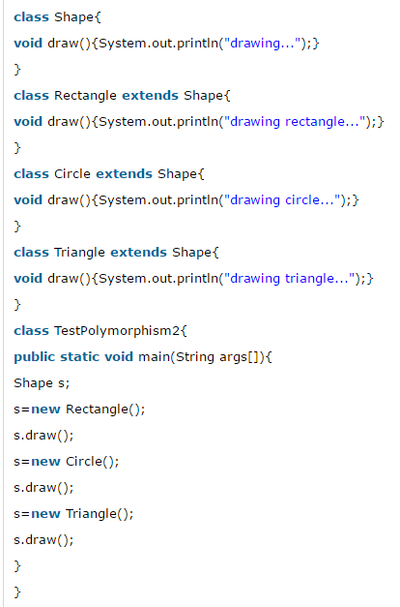 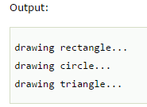

## **Java Runtime Polymorphism with Data Member->**

Method is overridden not the datamembers, so runtime polymorphism can't be achieved by data members.

Example->

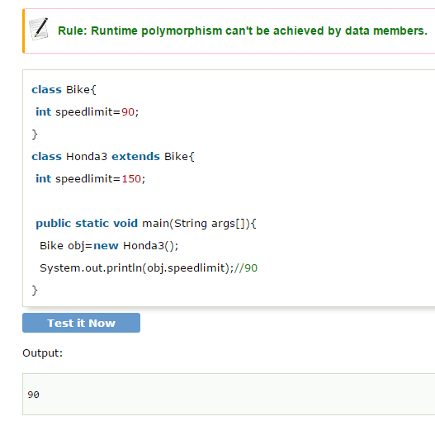

Static binding and Dynamic binding->

Here binding is Connecting a method call to the method body is known as binding.

Two types ->1.SB 2.DB

1.Static Binding->

*When type of the object is determined at compiled time(by the compiler), it is known as static binding.

*If there is any private, final or static method in a class, there is static binding.

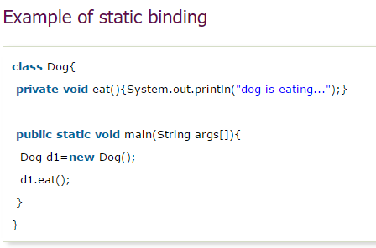

2,Dynamic Binding->

When type of the object is determined at run-time, it is known as dynamic binding.

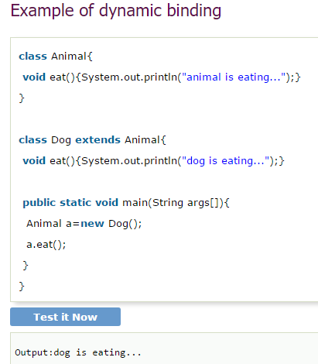

In the above example object type cannot be determined by the compiler, because the instance of Dog is also an instance of Animal.So compiler doesn't know its type, only its base type.